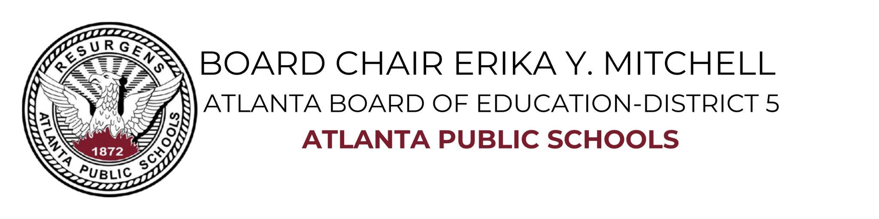
Supporting Documents/Publications:
- Atlanta Public Schools reaches all-time graduation rate high of 88.4%
- 10.09 Atlanta Public Schools Reaches All-Time Graduation Rate High of 88.4 Percent
- Atlanta school board chair: We’re focused on raising literacy at all levels
- Atlanta Board of Education rolls out new policy to combat sex trafficking
- Universal Music to Expand ‘Bonus Tracks’ Early Career Development Program to Atlanta, Detroit
- (NSBA) Close to Home: Child sex trafficking is closer than you think, and policies, awareness, and training can help
- Multijurisdictional Human Trafficking Collaborative
- Issues in Education: Erika Mitchell | Training for the Future (Youtube Video)
- Issue in Education: Erika Mitchell | Atlanta Board of Education, District 5 Board Member
- NSBA Restorative Justice
- APS Press Release - https://www.atlantapublicschools.us/site/default.aspx?PageType=3&ModuleInstanceID=124234&ViewID=7b97f7ed-8e5e-4120-848f-a8b4987d588f&RenderLoc=0&FlexDataID=132145&PageID=72761
- Literacy Policy - AJC Article
- Sex Trafficking Policy - https://www.wsbtv.com/news/local/atlanta/atlanta-board-of-education-rolls-out-new-policy-to-combat-sex-trafficking/884126212/
https://airportchamber.com/multijurisdictional-human-trafficking-collaborative/
- OP-ED
- Rev. William Finch was a pioneer for equity in Atlanta schools https://www.ajc.com/opinion/opinion-rev-william-finch-was-a-pioneer-for-equity-in-atlanta-schools/SNAIGKIBI5F2XFV6XE6Z4ZP2PI/
- What do Atlanta schools owe Martin Luther King Jr.
https://www.ajc.com/opinion/opinion-what-do-atlanta-schools-owe-martin-luther-king-jr/FEFWESIR2RC57DVTSJF2WYN2UQ/
- President Jimmy Carter’s enduring legacy in Atlanta Public Schools https://www.ajc.com/opinion/opinion-president-jimmy-carters-enduring-legacy-in-atlanta-public-schools/K55VXACHIBA4NJBODBTLOUK4SU/

District Achievements and Partnerships:
- Capitol Records - after school program at Douglass high schools, students received 25,000 in scholarship and to intern at Capital records in Los Angeles
- Atlanta Falcons - donated cleats, gloves, apparel for Young middle school, John Lewis Invictus Academy, Mays, Douglass and Best Academy high schools
- University For Parents - District-wide, resource for parents (Equity)
- Georgia’s Own Credit Union - sponsored books authored by former NBA Theo Rafflit anti bullying and sponsored international trips for selected students
- Chick fil-A Cascade Rd - community partnership to support the Mays cluster schools, fundraisers and events (Mays high school’s Corky Kell Football pep rally)
- YouthSparks - Fulton County Juvenile Courts-intervention programs
- U First Project - Donation of school supplies, hygiene kits, and hygiene closet
- NFL Players Association Metro Atlanta Chapter - provide scholarships to graduating seniors
- 100 Black Men of America/ National Chair Mr. Thomas Dortch, Jr, sponsored principal dinners, sponsored student trips
- The Launch Pad - We Ready Together (tutoring program)
- Operation Hope - Donated 100 air purification systems to APS
- Goodr - Provide food for families, hand sanitizing station
- FODAC - Donated 51, 000 mask to APS District 5 schools
- Comcast Cares Day (May 4, 2019) @ Miles Elementary School
- Porsche Experience Center - school supplies donation for Woodson Park elementary school, under principal Dr. McClendon

Atlanta Board of Education’s Committee 2018-2021:
Equity Taskforce
Audit Committee
Legislative Liaison
Policy Review

Appointments 2018-2021:
Board of Director for the Atlanta BeltLine
City of Atlanta’s Mayor Bottom to serve on the Atlanta 2020 Census Committee
Collier Heights Neighborhood Association, Educational Chair
Georgia Statewide Human Trafficking Taskforce Workgroup

National Elected Office:
Urban Board Alliance Committee of the Consortium of State School Boards Associations (COSSBA).
Atlanta Public Schools Delegate for the Georgia School Board Association and the Council of Great City Schools.
Elected member of the National School Boards Association’s
Council of Urban Boards of Education’s Steering Committee, Vice Chair (2021)
- Chair Policy & Resolutions
Elected as Secretary on the National Black Council of School Board Members
- Chair Policy & Resolution

