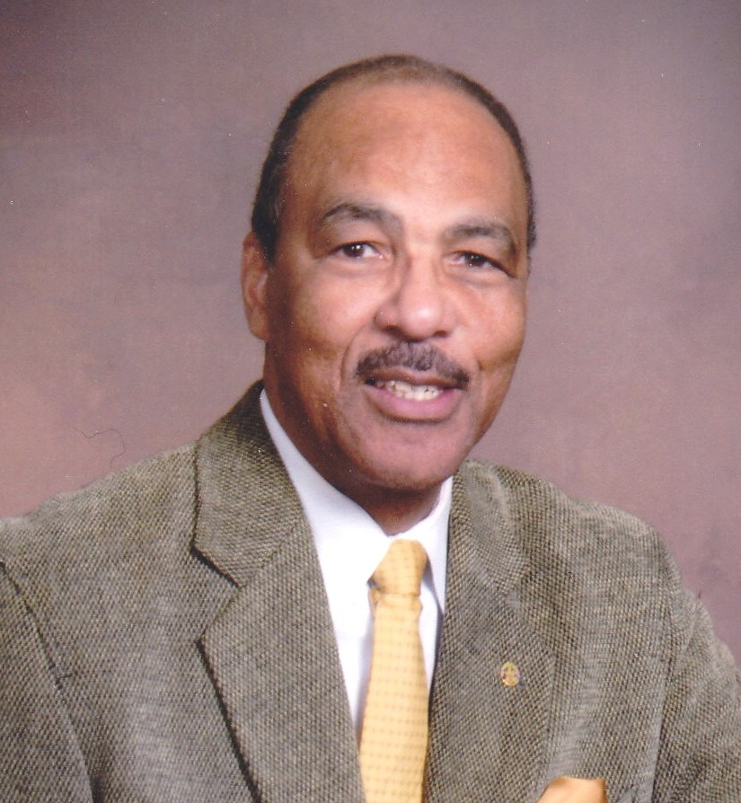

Accomplishments of Melvin Guider

1965 Graduated from Dunbar Vocational HS, Chicago, Illinois (Graduation Welcome speaker)
1971 Graduated from Midwestern University, Wichita Falls, Texas (Student president NAACP)
1971 Featured on Radio Station WBEE, “Young Blacks Doing Their Thing”
1971-72 Participant in National Teacher Corps, Cycle 4, Chicago, Illinois (Graduate degree/Special Education preparation program) Proviso East High School, Maywood, Illinois
1972 Awarded master’s degree, Northeastern Illinois University
1972 -76 Lockport Township HS, Dean of Students, Lockport, Illinois
1974 Recipient of the Fred Hampton Image Award (Educator)
1976-84 Lockport Township HS, Assistant Principal, Lockport, Illinois
1979 Became a member of Chicago ABSE and NABSE
1979 Became a member of Kappa Alpha Psi Fraternity Inc.
1984-89 Aurora East School District, Middle School Principal, Aurora, Illinois
1989 Recipient of Kappa Alpha Psi Fraternity, North Central Province, C. Rodger Wilson Humanitarian Award
1989-92 Houston Independent School District, Middle School Principal, Houston, Texas
1990 Became a member of Houston AABSE and Texas ABSE
1992-07 Houston Independent School District, B. T. Washington HS, M.B. Wesley Elementary Assistant Principal
1993 NABSE National 21st Annual Conference, Exhibits Chairman, Houston, Texas
1994-96 Elected President of the Kappa Alpha Psi Fraternity Inc. , Missouri City Alumni Chapter, Houston, Texas
1997 Inducted into the Dunbar Vocational HS Hall of Fame, Chicago, Illinois
2002-06 NABSE Legislative Chairperson
2004-18 Texas ABSE Legislative Chairperson
2005 Recipient of the TABSE Excellence Award
2006-18 NABSE Legislative Co-Chair to Dr. LaRuth Gray
2006-18 NABSE National Education Policy Institute (NEPI) Co-Chair to Dr. LaRuth Gray
2006-16 Texas ABSE Legislative Symposium Chairperson
2009 NABSE Life Membership
2009-22 Houston AABSE Election Committee Chairperson
2009-21 Texas ABSE Election Committee Chairperson
2018 Recipient of the first TABSE “Golden Life” membership
2021 Recipient of the Houston AABSE, Dr. Elaine Bailey, Heart of HAABSE Award
2021-23 Elected Texas ABSE Historian
2021-23 Texas ABSE Newsletter editor
2023-24 Texas ABSE Election Committee Chairperson
1979-2025 NABSE Annual Conference attendee (38 years)

