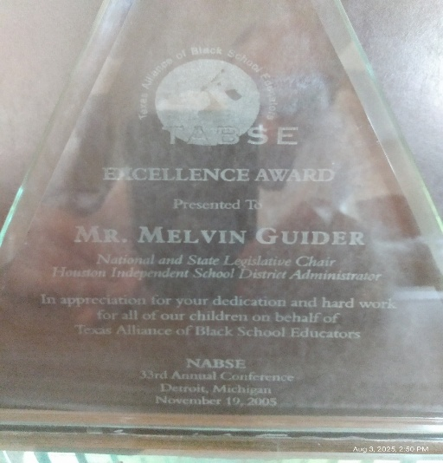
Melvin Guider
TABSE Excellence Award

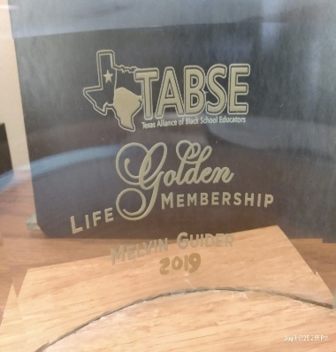
Melvin Guider
Golden Life Membership

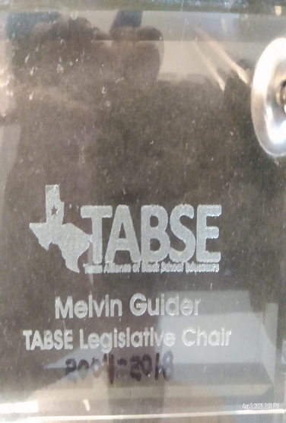
Melvin Guider
TABSE Legislative Chair Award

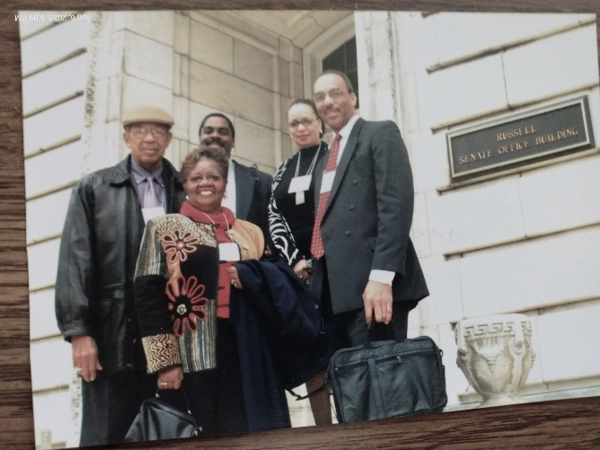
Melvin Guider
NEPI Senate Visit

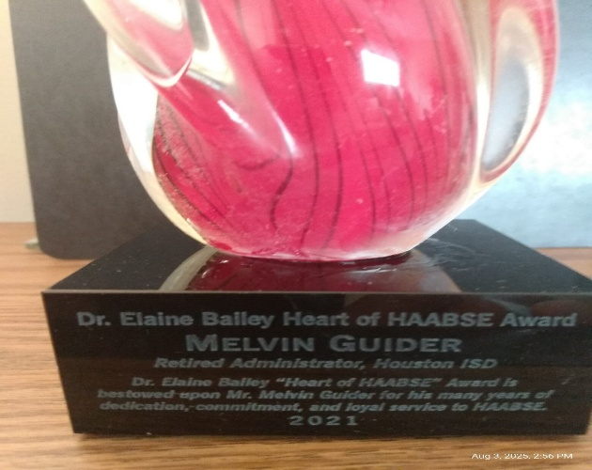
Melvin Guider
Heart of HAABSE Award

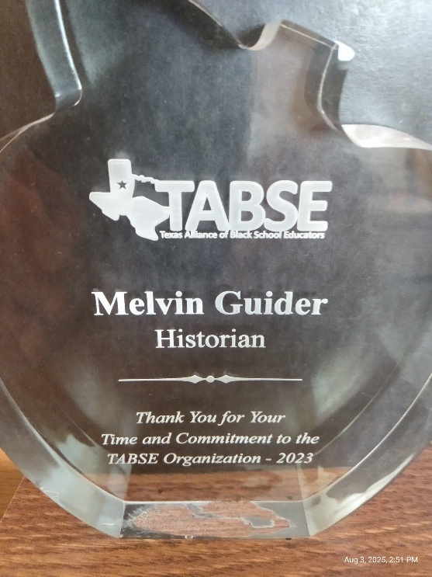
Melvin Guider
Historian Award

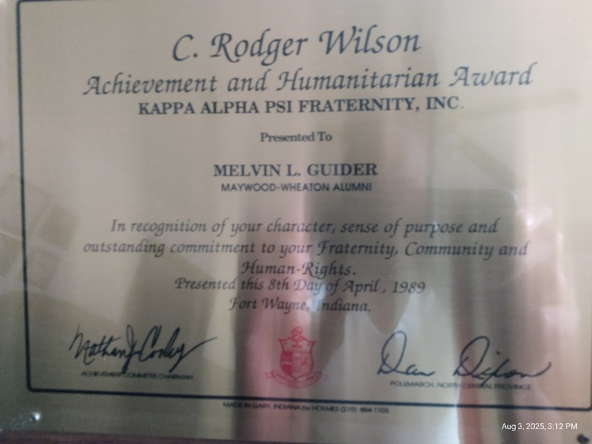
Melvin Guider
C. Rodger Wilson
Achievement and Humanitarian Award
KAPPA ALPHA PSI FRATERNITY, INC.

